

**German Jordanian University**

**Electrical Machines and Control LAB-** **ME535**

**Experiment’s Number: 4**

**Experiment’s Name: The three-phase induction motor performance and rotor.**

**Section Number: (1) Mon 2:00-4:00**

**Submission Date: 20/11/2023**

**Student’s Name: Student’s ID Number**

**Mohannad Mahfouz 20191102056**

**Aws Barghouthi 20189105057**

**Ahmad Naamneh 20181105106**

**Part 1:**

**At 100% rated voltage:**

|  |  |  |  |  |  |  |  |
| --- | --- | --- | --- | --- | --- | --- | --- |
| **T (N.M)** | **n (RPM)** | **w(rad/s)** | **I(A)** | **Pout(W)** | **Pin (W)** | **η (%)** | **PF** |
| **No load** | **1493** | **156.34** | **2.27** | **0** | **188** | **0** | **0.13** |
| **0.5** | **1480** | **154.99** | **2.21** | **77.5** | **274** | **28.3** | **0.2** |
| **1** | **1471** | **154.04** | **2.27** | **154.04** | **350** | **44** | **0.25** |
| **1.5** | **1464** | **153.31** | **2.28** | **229.97** | **422** | **54.5** | **0.3** |
| **2** | **1455** | **152.37** | **2.31** | **304.74** | **495** | **61.6** | **0.35** |
| **2.5** | **1445** | **151.32** | **2.34** | **378.3** | **570** | **66.4** | **0.4** |
| **3** | **1435** | **150.27** | **2.39** | **450.81** | **655** | **68.8** | **0.44** |
| **3.5** | **1415** | **148.18** | **2.51** | **518.63** | **785** | **66.1** | **0.51** |
| **4** | **1397** | **146.29** | **2.65** | **585.16** | **916** | **63.9** | **0.57** |
| **4.5** | **1375** | **143.99** | **2.81** | **647.96** | **1070** | **60.6** | **0.62** |
| **5** | **1357** | **142.10** | **2.96** | **710.5** | **1180** | **60.2** | **0.65** |

$w=\left(\frac{2π}{60}\right)*n$ = $\left(\frac{2π}{60}\right)*1471$ =154.04

Pout=T*w=1*154.04=154.04

η = Pout/Pin = 154.04/350=44%

**Part 2:**

**At 50% rated voltage:**

|  |  |  |
| --- | --- | --- |
| **T (N.M)** | **n (RPM)** | **w(rad/s)** |
| **No load** | **1477** | **154.7** |
| **0.25** | **1450** | **151.8** |
| **0.5** | **1430** | **149.7** |
| **0.75** | **1412** | **147.9** |
| **1** | **1390** | **145.6** |
| **1.25** | **1368** | **143.3** |
| **1.5** | **1342** | **140.5** |

**Part 3:**

**20 ohms**

|  |  |  |  |
| --- | --- | --- | --- |
| **T (N.M)** | **n (RPM)** | **I (A)** | **w(rad/s)** |
| **0** | **1447** | **2.27** | **151.5** |
| **0.5** | **1350** | **2.27** | **141.4** |
| **1** | **1262** | **2.27** | **132.2** |
| **1.5** | **1191** | **2.27** | **124.7** |
| **2** | **1113** | **2.3** | **116.6** |
| **2.5** | **1022** | **2.34** | **107** |
| **3** | **928.6** | **2.4** | **97.2** |
| **3.5** | **794** | **2.49** | **83.1** |
| **4** | **716** | **2.55** | **75** |

**30 ohms**

|  |  |  |  |
| --- | --- | --- | --- |
| **T (N.M)** | **n (RPM)** | **I (A)** | **w(rad/s)** |
| **0** | **1435** | **2.3** | **150.3** |
| **0.5** | **1318** | **2.29** | **138** |
| **1** | **1213** | **2.3** | **127** |
| **1.5** | **1121** | **2.3** | **117.4** |
| **2** | **1031** | **2.33** | **108** |
| **2.5** | **929** | **2.37** | **97.3** |
| **3** | **788** | **2.41** | **82.5** |
| **3.5** | **707** | **2.45** | **74** |

**Graphs:**

**1-Torque Vs. Speed (100% and 50% rated voltage):**

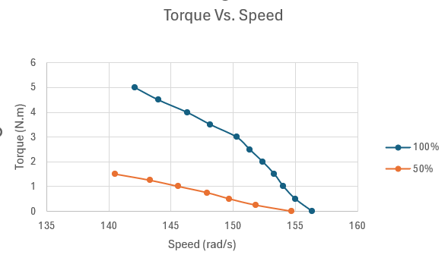

**2-Torque Vs. Speed (100% rated voltage and without resistors):**

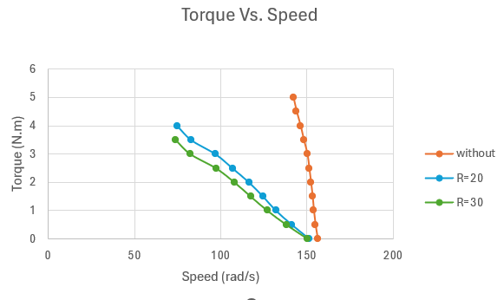

**3-Torque Vs. Current:**

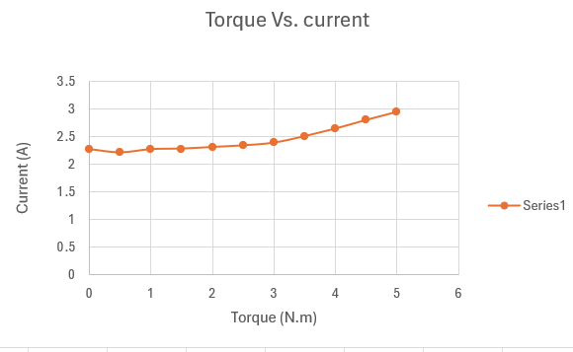

**4-Efficiency Vs. Torque:**

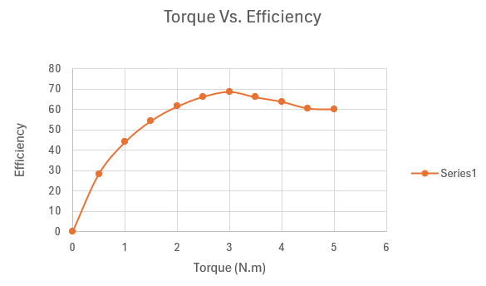

**5-Power factor Vs. Torque:**

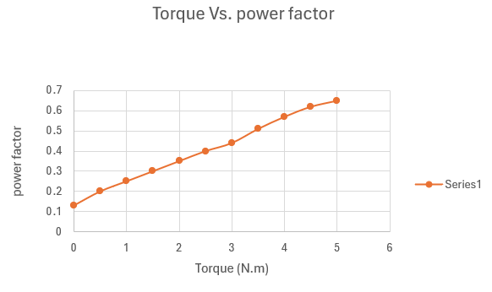

**Discussion**

**Conclusion**

Add pic

